A portable readout system for

Micro-pattern Gas detectors and Scintillation detectors

**Abstract**:

A system of readout electronics used in both Micro-pattern Gas detectors and Scintillator detectors is introduced in this paper. The system is intended as a general purpose multi-channel readout solution for a wide range of detector types and detector complexities. A 32-channel charge sensitive ASIC VATA160 from IDEAS company is adopted in this method. With its features of high integration, low noise and large dynamic range, this system handles up to 128 electronic channels. With a integration time of 1.8 us, each channel’s dynamic range is from -3pC to +13pC with a noise of better than 2.5fC and nonlinearity of better than 0.5%. As a portable system, it is able to generate trigger itself or get external trigger. This system transfers data to a PC host and gets controlled by PC via only one Universal Serial bus (USB).

**Key words:** VATA160, ASIC, readout system, USB, MPGD, Scintillation detectors, Charge measurement

1. **Introduction**:

With the development of high energy physics (HEP) experiments, the micro-pattern gas detector (MPGD) and scintillation detector are widely used in particle detection physics and space astrophysics. As a high resolution particle tracking detector, the MPGDs has a variety of applications, especially for the Micro-megas [1] and Gas Electron Multipliers (GEMs) [2]. Thanks to the feature of high detecting efficiency and high dynamic range, scintillation detector is used in high energy physics like DAMPE [6] , AMS [7] and PAMELA [8], which have now reached maturity.

VATA160 is a high dynamic range charge measurement readout ASIC with self-trigger function designed by IDEADS (Norway). It has 32 charge sensitive channels. The ASIC is designed for scintillation detector and MPGD. An electronic system based on VATA160, which can acquire 128 channels of charge inputs, has been developed. This system can be used to research the performance of MPGDs as well as scintillation detectors. With a integration time of 1.8 us, the dynamic range is from -3pC to +13pC, and the noise is better than 2.5fC. This system is compact and portable to use. It communicates with the PC via only USB bus. Since its total dissipation is lower than 2.5W, it could be supplied by this USB bus. This system is able to generate trigger itself or get external trigger.

1. **Overview of VATA160**:

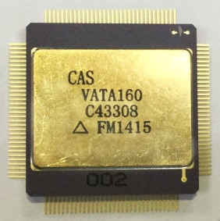

Figure 1 VATA160 Chip

VATA160, as shown in Fig. 1, is a 32-channel, low noise (better than 2fC) and high dynamic range (-3pC to +13pC) charge measurement ASIC designed by IDEAS Company (Norway). VATA160 is combined by VA part and TA part. The VA part is for charge measurement. Each channel of this part contains a charge sensitive preamplifier, a shaper circuit and a sample / hold circuit. The TA part is in charge of generating fast trigger signals. Each channel consists of a shaper circuit and a comparator. An adjustable reference voltage from outside is compared to the shaping amplitude produced by the shaper circuit. The TA part outputs a trigger signal in the case that any of 32 channels’ shaping amplitude exceeds the reference voltage.

1. **Implement of readout system**:



Figure 2 block diagram of electronic board

The block diagram of electronic board is given in Fig. 3. It mainly consists of 4 VATA160 chips, 4 Analog to Digital Converter (ADC), a Field-Programmable Gate Array (FPGA), 2 Digital to Analog Converter (DAC) and a USB interface chip. Each VATA chip has a connector of 2*32, 50mil double row pins, which is very common in detectors, as interface to detectors. Since the MPGDs often have sparks, which may damage the measurement channel of VATA160, the Electro-Static Discharge (ESD) protection is necessary to the system. The Chip NUP4114, which can bear the ESD of 16000V Human Body Model (HBM) or 400V Machine Model (MM), is adopted in every input channel. The VATA160’s input range is from -3pC to +13pC and the noise is 2fC, which determines that the effective number of bits (ENOB) must be better than 13 bits so that the converter can cover all ranges. Considering the maximum reading out rate is 500kHz, the ADC of AD7944 is used in this system. AD7944 is a PulSAR ADC with 14-bit resolution without missing codes, and the ENOB is 13.5 bits. [11] Its throughput is 2.0 MSPS and the dissipation is low to 15.5 mW. In order to limit power consumption so that the system can be supplied by USB cable, which provides up to 2.5 W power consumption. The FPGA SmartFusion2 from Microsemi company is adopted to control the system. SmartFusion2 is flash-based FPGA fabric, which results in extremely low power design implementation with static power as low as 7 mW. According to past experience, the max dynamic power is 500mW. The chip CY7C68013-A is taken as USB interface to transfer data to PC and receive controlling commands. The transmission rate of USB2.0 protocol is 480 Mbps, which meets the needs of the system. The DAC is used to set threshold for TA part, so that the triggers can be generated.



Figure 3. Calibration circuit

Since the system needs calibration before using every time, the automatic calibration function has been designed on board. The diagram is shown in Fig. 3. It’s mainly composed of a DAC, an analog switch and a capacitance. To simulate the charge from detector, a controllable step voltage is generated by analog switch. Then the capacitance turns the step voltage into current pulse, which is injected into VATA160 chip’s input channel. By controlling the shift register of VATA160, all the input channels can be tested one by one.

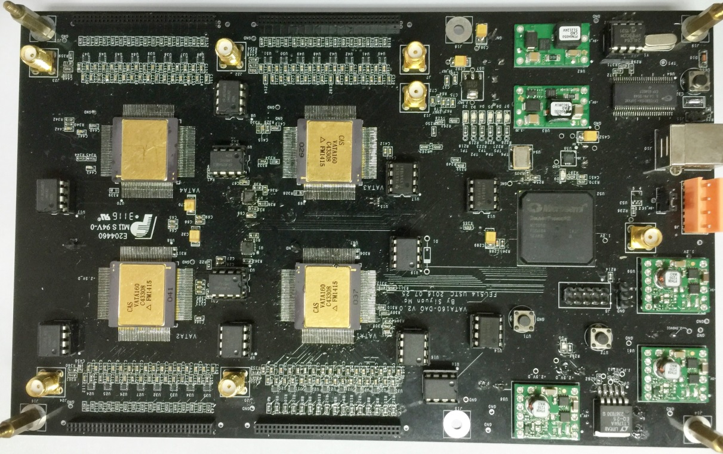

Figure 4 implement of the readout system

This portable readout system has been implemented as shown in Fig. 9. This system is convenient to use. It acquires the detector’s signal either from an external trigger or an internal trigger generated by VATA160. The data is transferred to PC host through a USB cable, which is also responsible for power supply of hardware and transmission of control commands from PC to hardware. Besides, a shielding box is designed and made for this system to shield external noise.

The system is controlled by a Graphical User Interface (GUI) written in LabWindows and running on a windows PC.

1. **Performance of readout system**:

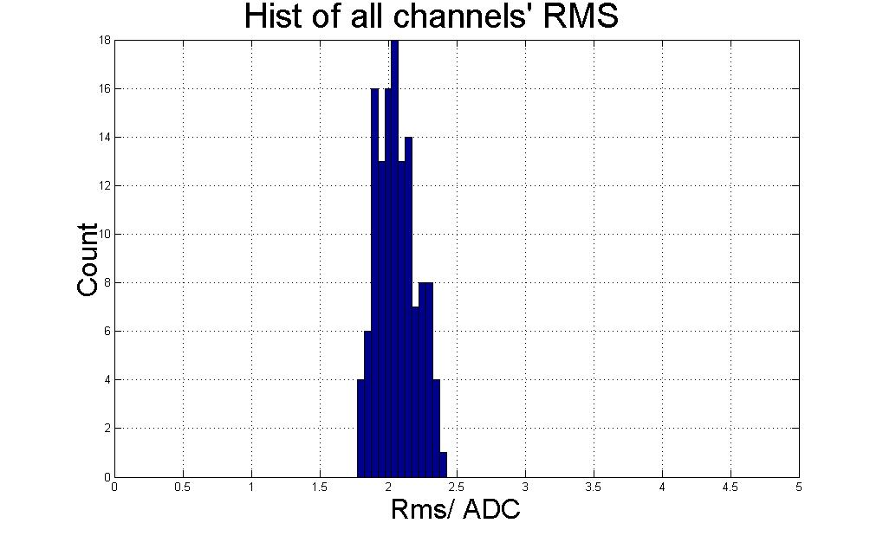

Figure 5. RMS of all Channels

In this section, we present the results of performance test of the readout system. The electronic noise was test and the result is shown in Fig. 5. The figure indicates that the noise of every channel is better than 2.5fC.

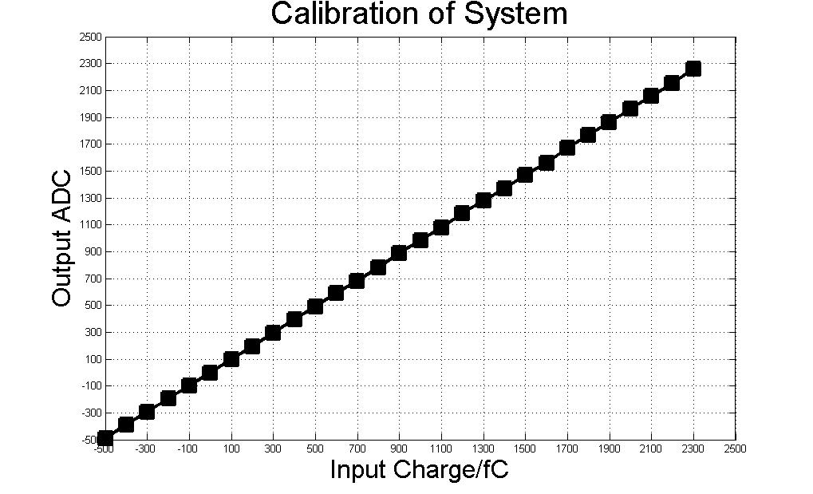

Figure 6. Calibration of One channel

Due to the VATA160 chip having calibration circuits, the automatic calibration function was implemented on the system. A Digital-to-Analog converter (DAC, TLV5618) and an analog switch (ADG741) controlled by FPGA are used to generate step pulses with different amplitudes. There is a 10pF capacitor on the board between switch and VATA160 chip, through which the pulse is turned into a certain charge pulse with an amplitude covering the full range of the ASIC. Then the charge is injected into each channel of VATA160 chip one by one and the results are gotten and packaged by FPGA. As is shown in fig. 6, the typical results of integral nonlinearity (INL) between -500fC to +2.5pC is better than 0.5%.

This system was coupled with a Micro-megas detector to test the energy spectrum of 55Fe. The result is shown in Fig. 6. The all-around peak and escape peak are clearly visible, which means the readout system is capable of performing the readout of Micro-megas detector.

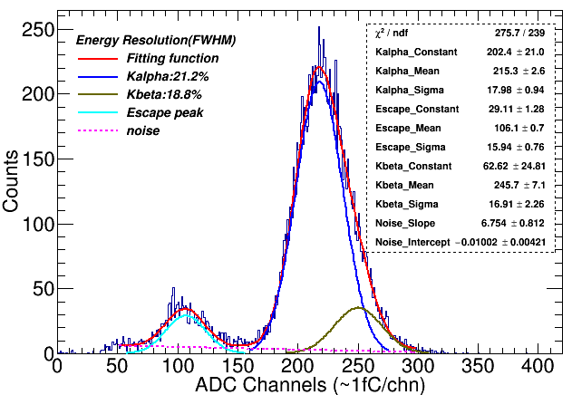

Figure 7. The spectrum of 55Fe

The encoded multiplexing readout method for Thick Gas Electron Multiplier (THGEM) is a novel method which can significantly reduce the number of readout channels. [10] In this part, the readout system is connected to a THGEM detector with the Two-Dimensional direct coding readout of 100*100 anode bar to perform imaging test. There is a copper plate with letter slits between the detector and X-ray generator. After collecting the X-ray signal which enters the detector through the slit of the copper plate, the two-dimensional imaging is obtained by decoding the hit position of the incident signal. As is shown in Fig. 11, the letter gap is clearly visible when the threshold is chosen to triple the noise.

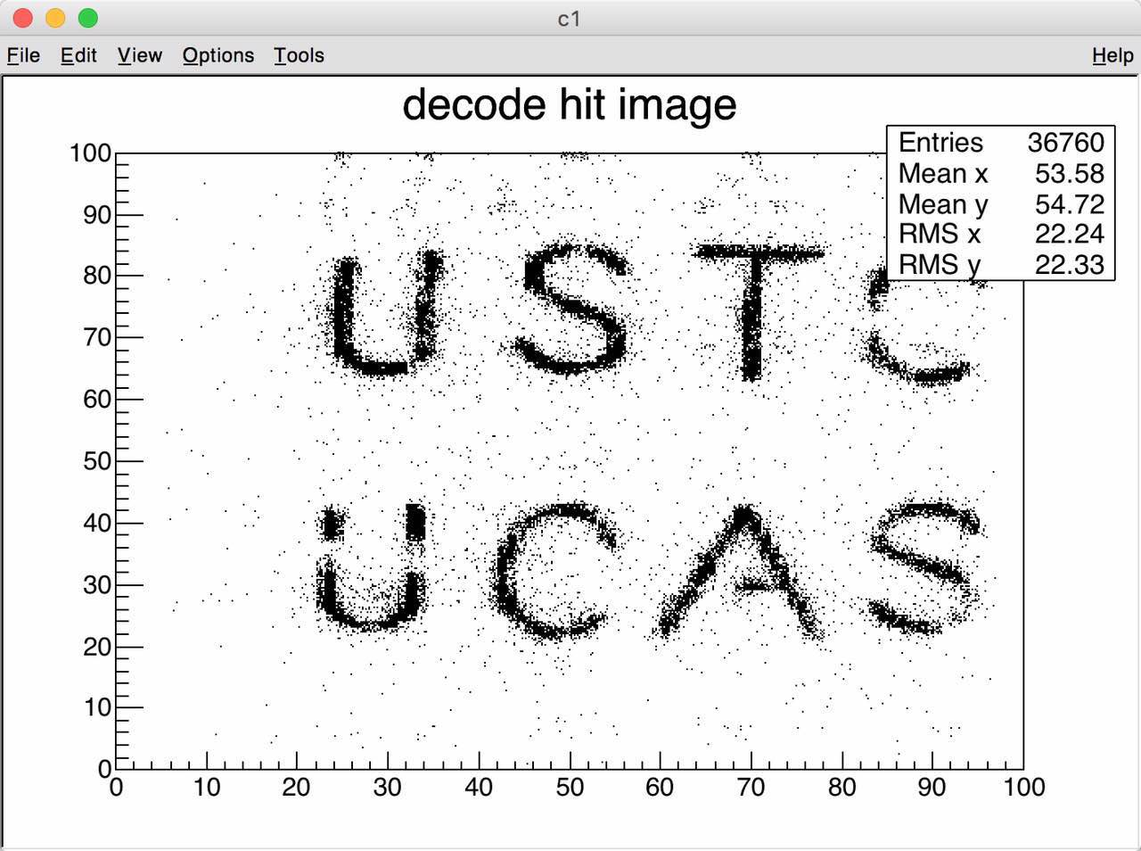

Figure 8. The results of decoded image

1. **Conclusion**:

A portable readout electronics system for MPGDs and Scintillation detectors are presented in this paper. It shows the readout systems has features of low noise (less than 2.5fC), high dynamic range (-3 ~ +13pC), low power dissipation (less than 2.5W) and high integration (128 channels). This system is portable to use with only one USB bus for its supply, commands and data transmission. This system can operate with different types of MPGDs and Scintillation detectors.

**Refference**:

[1] Y. Giomataris, et al., Nucl. Instr. Meth. A, 376: 29-35 (1996).

[2] F. Sauli, Nucl. Instr. Meth. A, 386: 531-534 (1997).

[6] Design of the Readout Electronics for the Qualification Model of DAMPE BGO Calorimeter

[7] Adloff C, Basara L, Bigongiari G, et al. The AMS-02 lead-scintillating fibres Electromagnetic Calorimeter[J]. Nuclear Instruments and Methods in Physics Research Section A: Accelerators, Spectrometers, Detectors and Associated Equipment, 2013, 714: 147-154.

[8] O. ADRIANI, M. BOSCHERINI, G. CASTELLIN et al. IL NUOVO CIMENTO, 1999, VOL. 112 A, N.

11:1317‐1323

[9] datasheet of NUP4114

[10] A novel method of encoded…

[11] datasheet of AD7944